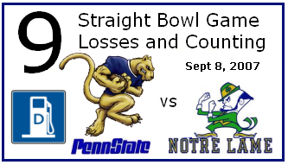
NEW LOCATION!! In RV lot 19 North of Ag Arena. Look for the checkered flag on our flagpole. Time: 0800 - ? dieseltailgate.no-ip.org & 2thelion.com
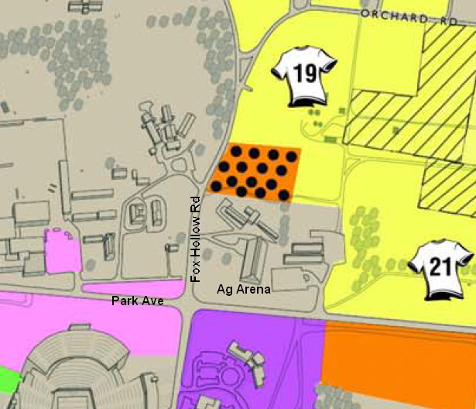

NEW LOCATION!! In RV lot 19 North of Ag Arena. Look for the checkered flag on our flagpole. Time: 0800 - ? dieseltailgate.no-ip.org & 2thelion.com

NEW LOCATION!! In RV lot 19 North of Ag Arena. Look for the checkered flag on our flagpole. Time: 0800 - ? dieseltailgate.no-ip.org & 2thelion.com

NEW LOCATION!! In RV lot 19 North of Ag Arena. Look for the checkered flag on our flagpole. Time: 0800 - ? dieseltailgate.no-ip.org & 2thelion.com

NEW LOCATION!! In RV lot 19 North of Ag Arena. Look for the checkered flag on our flagpole. Time: 0800 - ? dieseltailgate.no-ip.org & 2thelion.com

NEW LOCATION!! In RV lot 19 North of Ag Arena. Look for the checkered flag on our flagpole. Time: 0800 - ? dieseltailgate.no-ip.org & 2thelion.com

NEW LOCATION!! In RV lot 19 North of Ag Arena. Look for the checkered flag on our flagpole. Time: 0800 - ? dieseltailgate.no-ip.org & 2thelion.com

NEW LOCATION!! In RV lot 19 North of Ag Arena. Look for the checkered flag on our flagpole. Time: 0800 - ? dieseltailgate.no-ip.org & 2thelion.com

NEW LOCATION!! In RV lot 19 North of Ag Arena. Look for the checkered flag on our flagpole. Time: 0800 - ? dieseltailgate.no-ip.org & 2thelion.com

NEW LOCATION!! In RV lot 19 North of Ag Arena. Look for the checkered flag on our flagpole. Time: 0800 - ? dieseltailgate.no-ip.org & 2thelion.com

