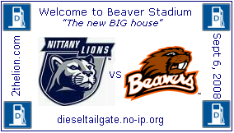
RV lot 19 North of Ag Arena: Look for the checkered flag and camo “8” on our flagpoles.
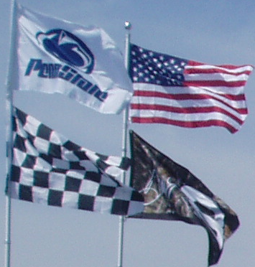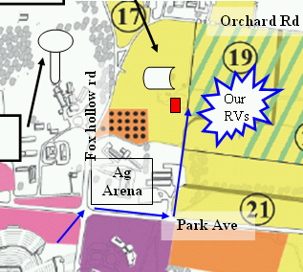
RV lot 19 North of Ag Arena: Look for the checkered flag and camo “8” on our flagpoles.

RV lot 19 North of Ag Arena: Look for the checkered flag and camo “8” on our flagpoles.
RV lot 19 North of Ag Arena: Look for the checkered flag and camo “8” on our flagpoles.
RV lot 19 North of Ag Arena: Look for the checkered flag and camo “8” on our flagpoles.

RV lot 19 North of Ag Arena: Look for the checkered flag and camo “8” on our flagpoles.

RV lot 19 North of Ag Arena: Look for the checkered flag and camo “8” on our flagpoles.

RV lot 19 North of Ag Arena: Look for the checkered flag and camo “8” on our flagpoles.

RV lot 19 North of Ag Arena: Look for the checkered flag and camo “8” on our flagpoles.

RV lot 19 North of Ag Arena: Look for the checkered flag and camo “8” on our flagpoles.

