In RV lot 19 North of Ag Arena: Flag = don’t give up the ship Time: 0800 - ?
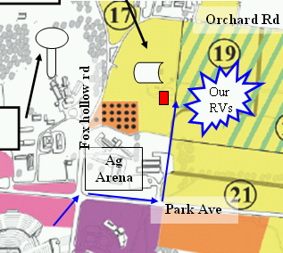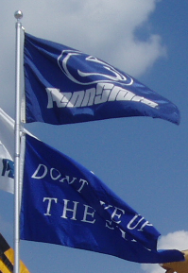

In RV lot 19 North of Ag Arena: Flag = don’t give up the ship Time: 0800 - ?

In RV lot 19 North of Ag Arena: Flag = don’t give up the ship Time: 0800 - ?

In RV lot 19 North of Ag Arena: Flag = don’t give up the ship Time: 0800 - ?

In RV lot 19 North of Ag Arena: Flag = don’t give up the ship Time: 0800 - ?

In RV lot 19 North of Ag Arena: Flag = don’t give up the ship Time: 0800 - ?

In RV lot 19 North of Ag Arena: Flag = don’t give up the ship Time: 0800 - ?

In RV lot 19 North of Ag Arena: Flag = don’t give up the ship Time: 0800 - ?

In RV lot 19 North of Ag Arena: Flag = don’t give up the ship Time: 0800 - ?

In RV lot 19 North of Ag Arena: Flag = don’t give up the ship Time: 0800 - ?

