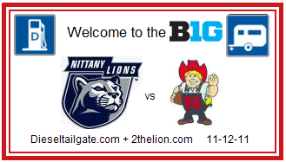
In RV lot 19 North of Ag Arena: Flag = “don’t give up the ship” Time: 0800 - ?
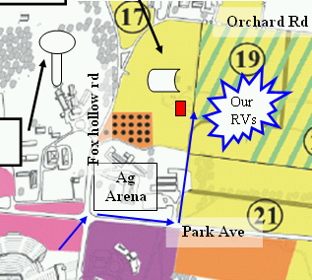

In RV lot 19 North of Ag Arena: Flag = “don’t give up the ship” Time: 0800 - ?
In RV lot 19 North of Ag Arena: Flag = “don’t give up the ship” Time: 0800 - ?

In RV lot 19 North of Ag Arena: Flag = “don’t give up the ship” Time: 0800 - ?

In RV lot 19 North of Ag Arena: Flag = “don’t give up the ship” Time: 0800 - ?

In RV lot 19 North of Ag Arena: Flag = “don’t give up the ship” Time: 0800 - ?

In RV lot 19 North of Ag Arena: Flag = “don’t give up the ship” Time: 0800 - ?

In RV lot 19 North of Ag Arena: Flag = “don’t give up the ship” Time: 0800 - ?

In RV lot 19 North of Ag Arena: Flag = “don’t give up the ship” Time: 0800 - ?

In RV lot 19 North of Ag Arena: Flag = “don’t give up the ship” Time: 0800 - ?

