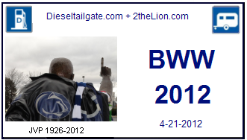
University Dr
West of the stadium near the pressbox and the carnival. Time: Saturday all day
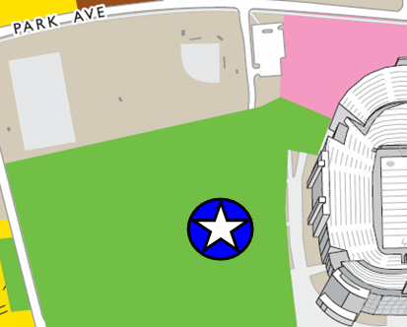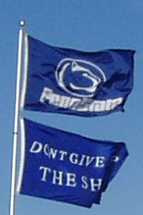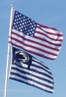

West of the stadium near the pressbox and the carnival. Time: Saturday all day
West of the stadium near the pressbox and the carnival. Time: Saturday all day
West of the stadium near the pressbox and the carnival. Time: Saturday all day
West of the stadium near the pressbox and the carnival. Time: Saturday all day
West of the stadium near the pressbox and the carnival. Time: Saturday all day

West of the stadium near the pressbox and the carnival. Time: Saturday all day

West of the stadium near the pressbox and the carnival. Time: Saturday all day

West of the stadium near the pressbox and the carnival. Time: Saturday all day

West of the stadium near the pressbox and the carnival. Time: Saturday all day

