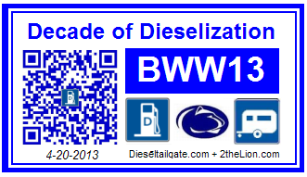

**University Dr**

**West of the stadium** near the pressbox and the carnival. Time: Saturday all day

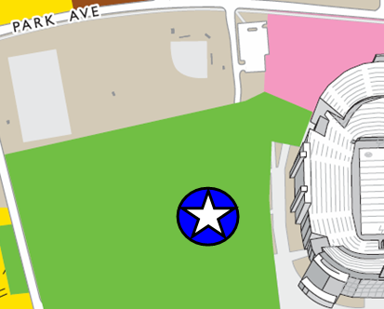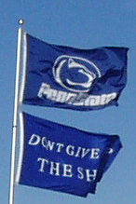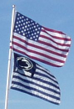

**West of the stadium** near the pressbox and the carnival. Time: Saturday all day



**West of the stadium** near the pressbox and the carnival. Time: Saturday all day



**West of the stadium** near the pressbox and the carnival. Time: Saturday all day



**West of the stadium** near the pressbox and the carnival. Time: Saturday all day



**West of the stadium** near the pressbox and the carnival. Time: Saturday all day



**West of the stadium** near the pressbox and the carnival. Time: Saturday all day



**West of the stadium** near the pressbox and the carnival. Time: Saturday all day



**West of the stadium** near the pressbox and the carnival. Time: Saturday all day



**West of the stadium** near the pressbox and the carnival. Time: Saturday all day

